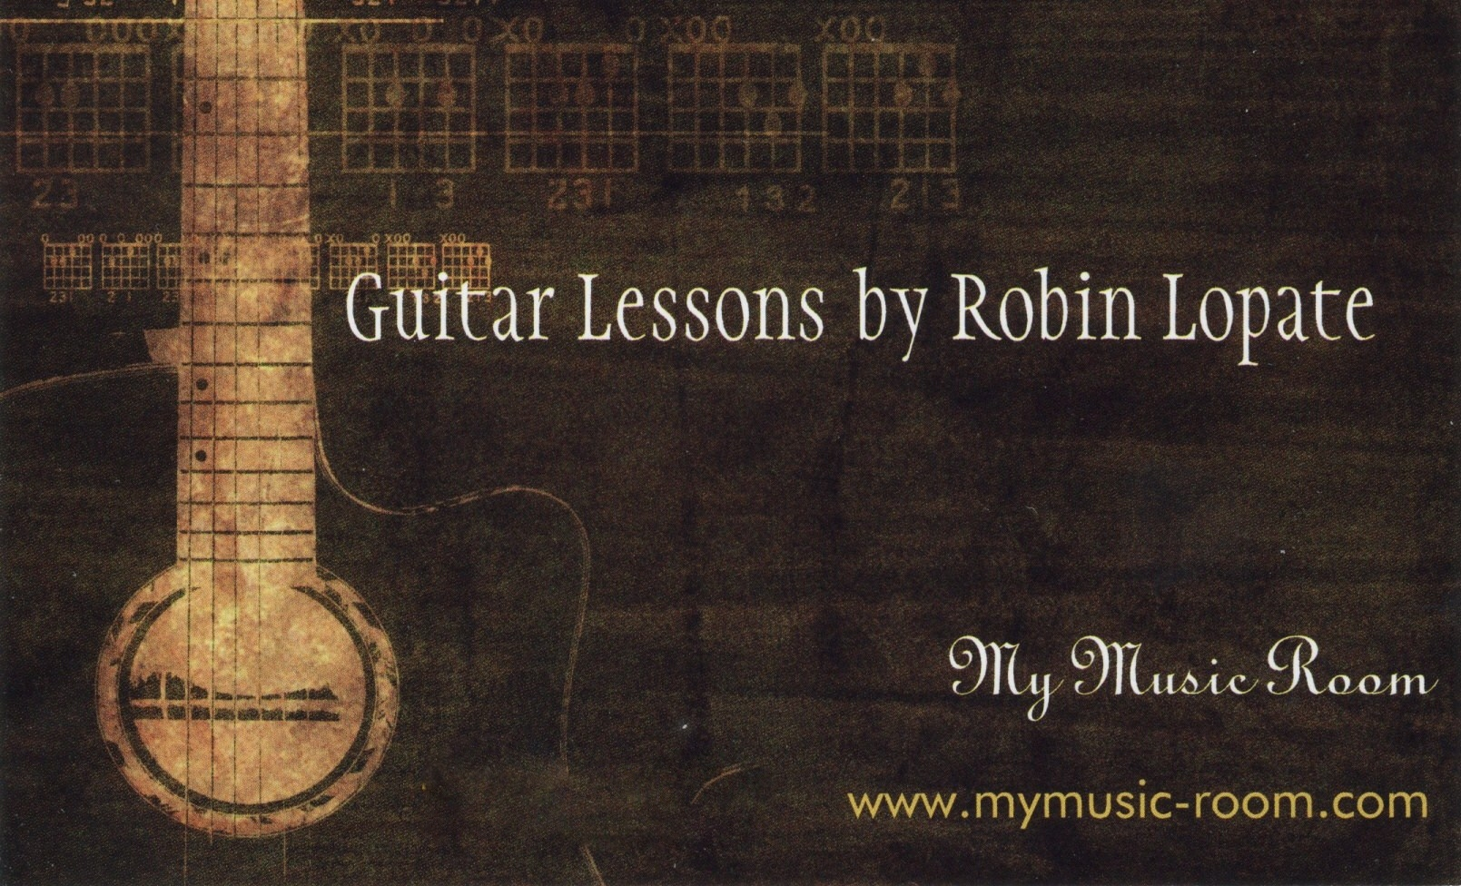

My Music Room - Guitar Lesson Policy Agreement.
- TUITION: The fee for 1/2-hour guitar lessons is $30.00/lesson, paid at each lesson. Blocks of 4 lesson payments are also preferred and encouraged ($120.00 for 4 lessons). 1-hour lessons can be arranged if appropriate and if schedule allows.
- MATERIALS: Students must have their own guitar and a playing pick. A 1” binder and some dividers are also required at the start of the session. Other materials may be recommended, but not required.
- MISSED GUITAR LESSONS –lessons will meet weekly for ½-hour, unless otherwise arranged. Please do your best to be prompt and to follow through with our scheduled sessions. If you are running late, please notify me a.s.a.p. As lessons are scheduled around each other, if you are running late you will be charged the full amount of the planned lesson even if we are only able to meet for a fraction of the time. If you are not able to make it to a lesson for some reason, at least a 24 hour notice is requested. Without a 24-hour notice, you will be charged for the lesson. Make up lessons can be arranged if given proper notice. In the unlikely event of an emergency or illness, “cancellation grace” (rolling the cost of the cancelled appointment to cover the cost of a rescheduled lesson) may be extended and is always subject to the teacher’s discretion. No refunds for prepaid lessons, however lessons may be transferred to a third party and/or used within 6 months.
- PRACTICING – students will be asked to practice at least 15-25 minutes/day. It is important that you adhere to this, as without practice, very little progress will be made on the guitar.
A note of encouragement to students and parents
Learning to play the guitar was one of the best decisions I ever made, and playing the guitar and singing has been one of the most rewarding things that I have done in my life. Honestly, if it was EASY to learn how to play the guitar, everyone would be doing it. The rock stars you see on TV make it look easy, and once somebody reaches a certain level of ability on the guitar, it certainly doesn’t require much effort to play well…but getting to that point is NOT an easy task. And it shouldn’t be!
Think about it: anything in life that’s worth doing…worth pursuing…worth mastering…takes work. Whether it’s finishing college, keeping a marriage together or moving up in your career, if it’s worth doing, it’s also worth fighting for, right? Guitar is no different. It can be one of the most rewarding things you ever choose to pursue in your lifetime and it can add tremendous value to your life, but it’s not easy…especially at first.
Unlike learning the piano, for instance, with the guitar, you have some of the hardest stuff to face at the very beginning. Your fingers and hands will rebel at first. Developing callouses and muscles in the hands will be a little painful and uncomfortable in the early stages of playing. You’ll have trouble with muscle memory, pattern recognition, keeping your fingers from muting other strings, changing between chords and a dozen other related skills that you have to get proficient at right at the very beginning. You WILL get frustrated! It really does get easier as you go, but the hardest part is right at the start.
I just wanted to throw that in, because some people will need to line up their expectations with reality. Regardless of what you want to be able to do on the guitar, it’s best to know what you’re about to face from the very beginning, so you can adjust your expectations accordingly. I will do my best, as your teacher, to pace you and help you to succeed as a guitarist.
Robin Lopate
I, , do acknowledge that I have received a copy
(Student’s Name Printed)
of the My Music Room Guitar Lessons Policy on this the of of 20 .
(Day) (Date) (Month) (Year)

Student’s Signature Date

Parent/Guardian’s Signature (if student is a minor) Date

